Enhancing Accessibility for Disabled Students through Video-Based Learning and Sign Language

Putri Irianti Sintaman¹, Ahyar Junaedi^{2*}, Mohamad Rafii³, Adhelwis Sekar Risdayanti⁴, Andykha Mujizatryo⁵
^{1,2,3,4,5} Universitas Muhammadiyah Palangkaraya, Indonesia
*Corresponding Author: sahaza777@gmail.com

ABSTRACT
This study focuses on addressing the accessibility challenges faced by students with disabilities in higher education by integrating sign language videos with PowerPoint presentations. The objective is to improve learning outcomes and inclusivity, particularly for students with hearing impairments. Using the ADDIE (Analysis, Design, Development, Implementation, and Evaluation) instructional model, the research developed a video-based learning system tailored to the needs of disabled students. Data were collected from students at faculty of business and informatics, palangkaraya muhammadiyah university. Findings reveal significant improvements in accessibility, engagement, and comprehension, with a 38% increase in material access and a 31% improvement in understanding complex concepts. The study concludes that incorporating sign language into educational content not only facilitates better learning outcomes but also promotes active student participation. This research highlights the potential for future development of assistive technologies to create inclusive learning environments in higher education..
Keywords: Inclusive education, Assistive technology, Sign language videos, Accessibility, Higher education
Article history
Received:  1 October 2024 | Revised:  20 October 2024 | Accepted:  17 November 2024 | Published:  16 January 2025
Citation (APA Style)
INTRODUCTION
The challenges to higher education access for persons with disabilities remain a key concern, and this is primarily exacerbated by the existing structures and failure to have adequate support. Although inclusiveness has been recognized internationally as an ideal approach to education, most higher learning institutions have difficulties addressing the different predispositions of persons with disabilities, which alters their social and academic perspectives. For instance, many disabled students have been subject to stigma, which can affect their willingness to announce their needs, thus failing to receive help (Edwards et al., 2022) (Lawlis et al., 2024). Often, common provisions like extensions of assignments and other academic changes are not applied sufficiently, especially among students with hidden disabilities (Edwards et al., 2022). Students also experience difficulties taking part in WIL (Work-Integrated Learning) due to the negative attitudes of the stakeholders and lack of training, which may lower their exposure to practical learning experiences (Lawlis et al., 2024). Applying universal design principles would create access-friendly educational settings that would not only cater to those with disabilities (Edwards et al., 2022). The ability of teachers, families, and support staff to collaborate is fundamental, but it is mostly significant when addressing the issues relating to children with disabilities (Vlcek & Somerton, 2023). Even the usage of a chatbot, which targets primarily able-bodied people, also stands to benefit individuals with intellectual disabilities as it aids in developing their communicative and social skills to integrate them all (Mateos-Sanchez et al., 2022). Although these solutions provide avenues to increase access, the enduring mismatch in the realization of the rhetoric and the reality signifies a need for continuous activism and transformation of the system's workings to allow education equity for all children with disabilities.
Higher education accessibility for people with disabilities in Indonesia is limited by poor infrastructure, the shortage of assistive technology, and scant availability of skilled manpower. Thus, this calls for creative approaches to enhance inclusive education. Providing other learning methods, such as sign language interpretation and captioned videos, is vital to assist with accessibility issues (Lawlis et al., 2024). Adapting universal design principles is suggested to all learners, which helps create a very adaptable learning system (Edwards et al., 2022). Inclusive assessment practice also covers addressing the needs of students with disabilities; in assessment evaluation, fairness is justified, which may be hard to implement (Tai et al., 2023). How students can engage in the process of assessing the design can help students understand their voices and needs, which will help create a better environment for them (Tai et al., 2023). Accessible as these approaches may seem, stigma, institutional resistance, and other barriers to inclusion may still exist, and therefore, there is a need for sustained efforts toward inclusion in higher education.
The development of assistive devices plays a crucial role in improving the educational backgrounds of students with disabilities – principally through pictures and incorporating all members in carrying out common activities. The inclusion theory states that educational systems should cater to every student rather than a few. This system encourages various approaches, such as differentiation and self–directed learning. Deaf student assistive technologies, particularly automatic sign-language interpreting systems, help in real-time communication in class for students who are hard of hearing, especially in developing economies (Amangeldy et al., 2022). Interactions with audio and tactile graphics enable blind students to acquire visual information from different sensory channels, thus increasing their knowledge of the content (MaćKowski et al., 2023). Devices meant for children with Autism Spectrum Disorder (ASD) support training in social and communication skills, which helps them adapt to school environments (Cañete & Peralta, 2022). Accessible educational content is exemplified also by the possibility of collaborative editing of captions of instructional videos (Bhavya et al., 2022). However, while these advances offer great potential, there are still issues concerning equal access and allocation of technology and resources to all demographic categories, particularly low-income ones. Starting from education, for example, if the digital divide is not addressed here, then any group of individuals can never achieve the real inclusion of all groups (Liddle, 2023).
The focus of this research is to fill the accessibility gap by using a video-based learning system that combines PowerPoint slides with sign language videos, which greatly improves the accessibility for disability students. This new way of doing things is not just to make the lesson exciting and comprehensible but also to enhance educational results within tertiary institutions. The addition of sign language videos is targeted toward deaf students for effective communication, thus catering to the needs of students affected by communication barriers (Amangeldy et al., 2022). The incorporation of sign language in educational video aids makes it possible to convert educational materials to signs, which enhances the learning process. Interventions such as integrating additional signs into a learning approach are factors that have been shown to increase the level of participation of deaf learners to higher levels than when no signs are used (Luangrungruang & Kokaew, 2022). Integrating multiple elements, for example, multimedia, helps to facilitate the learning process by covering different layers of learning (Barros et al., 2023). Concerning this, the author reiterates that such collaboration is essential when deploying such video learning materials within the faculties of the university to accommodate all students with disabilities (Lawlis et al., 2024). An example of this is the ability of her proposed system to be modified easily for use in any educational structure for both the disabled and the non-disabled (Amangeldy et al., 2022). On a positive note, the orientation towards technology-based interventions is challenging due to other factors, such as the need to train the competent authorities to use the technology and the proportion of the technology per institution.
Through this study, we also seek to contribute to further research on assistive technology for inclusive education by providing a statistical analysis of the use of video learning resources in the education of the disabled. This research exemplifies the need to develop functional learning environments and advance education technologies to effectively deliver education to all students.
METHOD
In this research, the author supports and develops an integrated video learning system on sign language for inclusive classrooms using a structured ADDIE (Analysis, Design, Development, Implementation, and Evaluation) model. The systematic or stepwise approach of the ADDIE model is useful for developing and evaluating a PowerPoint video augmentation system of sign language for young learners in an inclusive classroom. This model has a series of steps, and this is a good thing since it allows for a feedback mechanism where the project is updated, improved, or corrected after every step in the project.
As such, these steps facilitate quick intervention to mitigate the challenges faced by students with disabilities. The stages of ADDIE apply well to the present work because they are appropriate for the spiral instructional design model and provide for changes at the end of every stage evaluation.

Research Subjects
The research was performed on two groups: 1) students with disabilities taking part in the Digital Business Study Program at Muhammadiyah Palangkaraya University and 2) the teaching staff who took part in their teaching. In the initial stage, the student prototype trial focused on two students with sensory (hearing) disabilities. The learners were chosen using learning accessibility as a criterion and limitations on access to conventional educational content.

Research Procedure
The research was based on the five main stages of ADDIE, as described in the following examples:

1. Analysis:
At this stage, comprehensive sedentary desk analysis of students’ needs focused on those with disability. Among the needs addressed was physical and sensory access to learning resources. The researcher also looked at the shortfalls of a learning system that emphasizes using PowerPoint presentations with textual content devoid of any picture or sound to facilitate understanding of the expressed ideas. In addition, issues related to physical and sensory access to lectures, whether online or in person, are also analyzed (Amangeldy et al., 2022).

2. Design:
In coherence with the need analysis, a curriculum development technology that included sign language videos in PowerPoint presentations was developed. Part of this design procedure revolves around the identification of the aspects of the course content that will be digitally recorded for sign language and non-sign language videos, storyline concept, imaging and video quality, and video interactivity. That is, inclusiveness is key—making the materials informative and appealing to normal students and to those with disabilities (Shea et al., 2021).

3. Development:
In light of the system design being endorsed, prototype development commenced. The prototype's backbone was a learning video containing PowerPoint and sign language, designed using Adobe Premiere and CapCut. The learning resources were recorded, edited, and modified according to professional standards to suit the specified accessibility requirements. During this phase, the researcher focuses on providing appropriate content for the developed program with satisfying visual and aural quality usable on multiple devices and platforms (Amangeldy et al., 2022).

4. Implementation:
After the development process, the model is implemented in an actual learning environment. Students with disabilities used such video materials for one complete semester. The researchers trained faculty members and students on the application of the new teaching resources, including techniques for video access and the use of other interactive components. This is done in online and offline lessons to examine the system's practicality and adaptability in different learning conditions (Officer et al., 2023).

5. Evaluation:
The Evaluation stage is done at intervals to determine the extent to which the system has promoted access and quality of learning. The data collected during this phase include measures of effectiveness such as usage logs, technical issues encountered, and student performance. Additionally, the prototype's effectiveness is assessed by gauging undergraduates’ comprehension of the given material before and after exposure to the prototype. The researchers also studied learning achievements and the general activity of students in remarks and homework (Vlcek & Somerton, 2023) (Micsinszki et al., 2022).

Data Collection Technique
Data was obtained straight from the learning system, for example, data about the video access habits of a disabled student, times of access, and duration of viewing. Student assessment records were also added as data in order to check the relationship between assistive devices and educational level. Quantitative information was processed using descriptive statistics to assess the system's extent and effectiveness. At the same time, qualitative data generated from on-the-spot observation during implementation was used to improve and further refine the video prototype.

Data Analysis
The analytic method employed was comparing data before and after the system implementation. The scholars compared the academic performance and level of engagement of the students in the old system before the introduction of the new system and the engagement after the new system had been implemented. Improvement of grades and participation became the first metrics of this system's efficiency. All barriers or challenges encountered during implementation were systematically evaluated to proffer a way forward for enhancement in the next cycle.
This study is anticipated to be extended to other institutions of higher education that have disabled students within the framework of the ADDIE processes. The achievement of every stage is based on the knowledge of needs caused by disabilities..
FINDINGS AND DISCUSSION
Findings
This analysis outlines the results of each phase of the ADDIE model to showcase the success of a PowerPoint and Sign Language Orientation video learning system for special needs students. In this part, we analyze the data, present the results, and use some tables and graphs for better illustration.

1. Analysis Stage: Assessment of Accessibility Requirements
Within the framework of the Analysis stage we found out that text-based learning resources are inaccessible for most students with disabilities unless there is a provision for audio or sign language translations. Most of the students cannot keep up with materials presented in a conventional fashion. On top of that, there is little physical access to the educational materials and there is no technology in place to offer assistance to the students.

Table 1. Accessibility Needs of Students with Disabilities
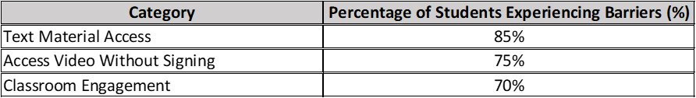

The details of the perceived accessibility requirements of the disabled students prior the incorporation of the video and sign language based learning system have been explored as shown by table 1 below. From the above table it is evident that 85% of students get some form of barrier when it comes to text materials and therefore learning material which is more graphical or in forms of sign language is required. Moreover, it was clear that 75% of the students struggled to understand the learning video that did not have sign language assistance. Students in class were also passive and 70% said that they had problems in participating fully in class. Thus, this data impose the need to enhance access to learning through state-of-the-art technologies and tools that addresses the disability needs of students.

2. Design Stage: Designing the Learning System
During the Design stage, we developed an integration between PowerPoint and sign language videos to solve the problems stated in the design stage.

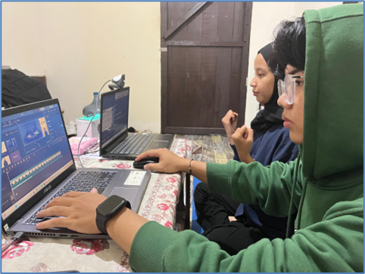
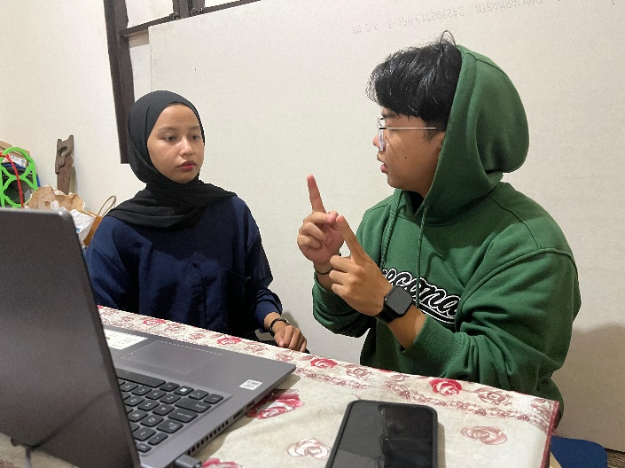

Figure 1. Learning video-making process

The video was designed with two main factors in mind:
Clear visualization of the material: using PowerPoint integrated with sign language explanations.

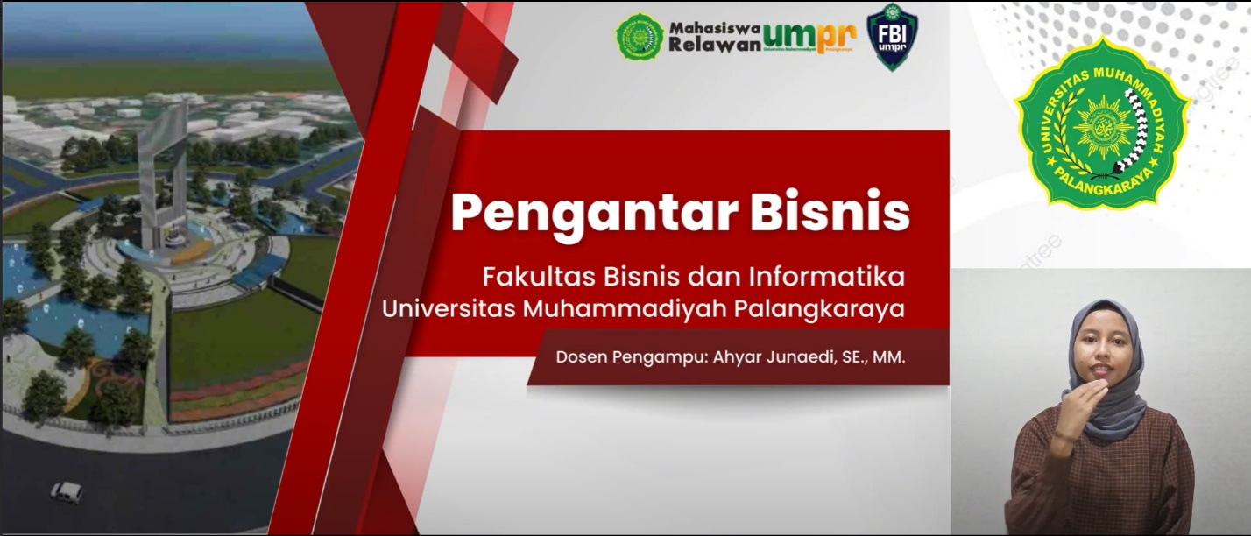

Figure 2. Video display in the form of powerpoint integrated with sign language videos.

The learning video demonstrated above was created for the “Introduction to Business” course Learning at the Faculty of Business and Informatics, Universitas Muhammadiyah Palangkaraya. The video is incorporated into an incoming learning innovation that synchronizes PowerPoint games with sign language interpreting to cater for the physically impaired students, especially those with hearing problems. The sign language video placed at the bottom in the video enhances every aspect of the learning material so that every student including the disabled students will be in a better position to understand the lesson.

Flexibility of access: Topics discussed in the videos can be watched when the student wants to watch them, either online or offline case which makes them learn as they wish.
The access of the prototype is going to be very general for use in any type of device and platform to reduce the technological hindrances towards accessibility.

3. Development Stage: Prototype Development
At the Development stage, the tutor creates the video-based learning environment that is to be used for disbursement of the teaching content using software tools like Adobe Premiere and After Effects. This system comprises the creation of an interactive video using visual aid materials from PowerPoint and sign language explanation.

Table 2. Key Features of the Learning System

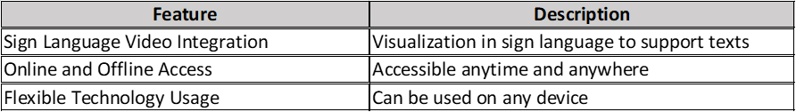

The main features in the learning system integrated with PowerPoint and sign language videos are summarized in Table 2. The first is the sign language videos: Representations in sign language for texts and presentations that helps disabled students comprehend what is being delivered. The second is availability or better still online and offline which enable students to access the materials at their own time and space hence flexibility of time and space. The last one is flexibility which means that the presented implements flexible technology that helps make sure that this learning system can be utilized across different devices to eliminate as many technological barriers to following the learning for the students. These three features in general sensitize the LMS to enhance accessibility and quality of learning for a wider category of learners including the disability. The developed system is tested in order to check that there does not exist a technical issue preventing students with disabilities from accessing the necessary materials.

4. Implementation Stage: System Implementation
Implementation stage in the development of the system involves deploying the design in a real learning context with two disabled students. The use of the system is observed for full a semester and gather all accessibility and learning effectiveness data.

Table 3. System Usage by Students with Disabilities

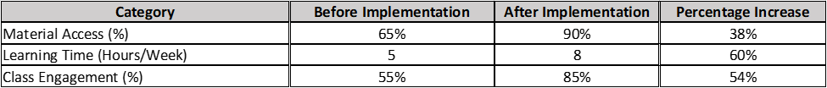

As seen in Table 3 above, it was also noted that the number of students with disability using the video-based learning system with sign language has been improving after the implementation. At the beginning only 65% of students could get access to the learning materials and this improved drastically after the implementation of the system to 90%. However, the actual study time per week was increased from 5 to 8 hours in order to show that the students were more engaged to deliver the knowledge after the system integration. Mean in-class student engagement also went up from 55% before the implementation of the system to 85% after implementation. Here evidenced that a video-based system for disability needs, identified to enhance student accessibility, engagement and time on learning.
The increase in accessibility and the students’ interactions with the system are the indicators of the attempts made on the realization of the system implementation. Students participate more during classroom discussion and are in a better position to grasp what is being taught when this video based system in used.

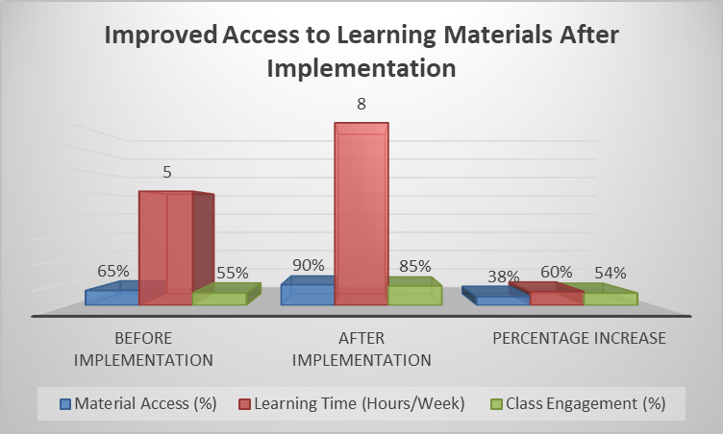

Figure 3: Improved Access to Learning Materials After Implementation

Figure 3 as a pre- and post-test survey of the video-based learning system with sign language in terms of availability of material, time on learning and class participation. The results for all the four categories improved greatly after the implementation of the various changes that had been suggested. The general access to materials improved from 65% to 90%,; learning time per week enhanced from 5hr, to 8hr; and student participation from 55% to 85%. These improve­ments depicture that the new system is able to enhance better access, as well as improve students’ involvement and dedication in learning.

5. Evaluation Stage: The measures of effectiveness of a system will involve the following;
In the Evaluation stage we are able to assess the learning outcomes of the video-based learning system and also students’ interaction level.

Table 4. Evaluation of Student Understanding Improvement

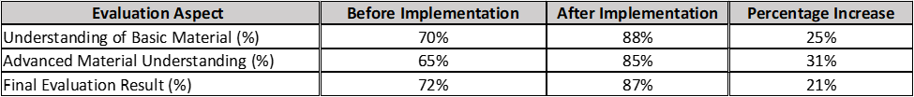

Table 4 indicates the progress made in the level of mastery of learning materials by the students after the introduction of the video based system and sign language. To support this, before the implementation the lesson plan assessment on the part of students on their comprehension indicated 70% of the basic facts and concepts while after the implementation this shot up to 88%. The level of advanced concept understanding also rose from 65% to 85% percent. By the end of the evaluation, other findings indicated that the effectiveness of the student learning outcomes was also enhanced, with an improvement of average percentage score from 72% to 87%. The results depicted on the figures above and above prove that the new learning systems are useful in assisting students, particularly the disabled, comprehend and excel in tougher material.
The findings establishes that using the video based learning system enhances students’ comprehension of content matter particularly where the content is complex in nature. Furthermore, through evaluation, it is found that students using this system got better academic results compared to the pre implementation period.

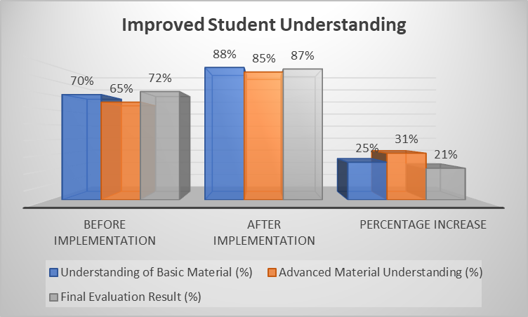

Figure 4: Improvement in Student Understanding

This bar graph demonstrates the effectiveness of learning growth before and after the using of video-based learning system and sign language. The pre implementation assessment of basic material was 70%, for advance material it was 65%, and the final evaluation result was 72%. The results show improvement after implementation where comprehension stood at 88% for basic material, 85% for advanced material and 87% for final evaluation. Advanced material portion increased by 31% while basic material portion increased by 25% The portion of final evaluation results also increased by 21%. This graph proves that the new system works to increase students’ knowledge and comprehension of material; specifically where the material is a bit harder to grasp.

Discussion
The use of video teaching aids, especially those with PowerPoint presentations accompanied by sign language, improves the ability of students with disabilities as seen in 38% increase in access to these learning materials after its introduction. This corresponds to inclusion theory which believes that all kids deserve equal opportunities while learning even those who are physically or sensorially challenged (Kim & Fienup, 2022). Such systems provide a useful complement, which is crucial to students who can’t manage ordinary reading texts (Gallagher et al., 2023). Besides, the concern of including all relevant parties, practitioners, parents and the like, in the educative process is very important in the promotion of inclusive education as explored in the existing literature (Vlcek & Somerton, 2023). The modern tools and teamwork can therefore help in ensuring that the educational process is more interesting to the children with disabilities (Lawlis et al., 2024) (Müller et al., 2024).
Moreover, the results revealed that the course materials were not only more accessible but the students’ understanding of the provided course materials also improved, more so on advanced mathematical concepts. This rise in comprehension is significantly tied to the usage of visual aids, for example, pictorial representation of information, for the students’ understanding of the content. In this connection, the use of sign language videos enhances the clarity of the PowerPoint presentation. Also, Evaluation results revealed a growth in understanding by 31% of the advanced material which suggested that this visual strategy helped students with disabilities a lot in understanding the ideas taught.
The students became more active after the implementation of the particular system. The increase in participation in class discussions by 54% also indicates that students encourage equal access to the materials in classes. This is inline with the active engagement theory which argue that student participate more in learning if they are better informed and have access to learning resources. In addition to principles of access, this unobtrusive and formative approach to increasing the use of video-based learning material also enhances the role of students in the learning process, encouraging them to participate more actively.
In conclusion, this study was able to make use of the ADDIE Model to create an effective learning system that caters for the needs of the learners who are disabled. The evaluation stage has demonstrated not only an increase in accessibility and understanding of the system, but also enhanced performance of students as well as participation in the learning experience. Video-based technologies and sign languages have been demonstrated in this research to be useful and creative resources that can be embraced to enhance catered learning in higher education settings. This innovation can be applied in many educational establishments for the regard of the disabled and their chances of performing well academically.
CONCLUSION
The implications of this study concerns the need to encourage the use of assistive technologies, where integration of PowerPoint presentation with sign language videos can be particularly helpful in supporting learning of disabled students in higher learning institutions. As mentioned in the introduction, it was our intention to increase availability and thus enhance equal opportunities regarding classroom participation. The outcome of the implementation and evaluation revealed that the system proved useful since learners with disability enhanced the comprehension of learning materials that were previously difficult for them, especially in the senior classes.
This research reflects on the inclusion theory in support of education for students with disabilities, or those who have specific needs in terms of physical or sensory interactions with the learning environment. The increase in material access, engagement in classroom discussions, and the performance improvements demonstrate that integrating multimedia can overcome barriers mitigations. This idea that one gets higher engagement and understanding after the development of such system implies that students particularly those with disability have a special need in receiving learning environment that can address their needs.
Furthermore, it is important to note that in addition to increasing the retention of basic materials taught in class the use of the video-base system also enhance the understanding of hard content as shown in the results above. The enhancement shown in the specific areas includes the improved understanding of advanced material by a boost of 31% and basic materials where understanding rose by 25% especially through the use of visual materials; sign language videos.
This study also discovered that the system led to a boost of students’ contribution toward class activities by 54% as observed in the system. This accords with the theories of active engagement, which require that the students be well endowed with learning materials in order to result to active engagement. The impersonal and less prominent nature of the video-based learning system provided this studying audience with an environment whereby, they became more engaged in the learning process on their own.
The strengths of this study therefore include practical implication of the findings for a group of students in a particular institution in relation to the future of inclusive education. The system that emerged from the ADDIE model can be complemented and implemented in other educational context and provide institutions aimed to assist students with disabilities a practicable solution. Additional research should be carried out to determine the effects of such systems on future academic performance besides determining how similar strategies can be applied in other settings.
Therefore, incorporating the use of videos with sign language has been an important approach of promoting the education of students with disabilities. This research expands the understanding of ID (Instructional Design) to enhanced learning for disabled students by the use of ICT (Information and Communication Technology), arguing that students with disabilities should be given similar chances in their academic success. The findings of the present research shall offer a solid ground for future research in this line given that the implementation of innovative solutions may help enhance the learning environment of student of all levels of education and different learning settings..

ACKNOWLEDGMENT
The authors would also like to extend their deepest thanks to Direktorat Jenderal Pendidikan Tinggi, Riset, Dan Teknologi, Kementerian Pendidikan, Kebudayaan, Riset, Dan Teknologi for their unfathomable support and grant that enabled this study to be conducted. We are also grateful to the Faculty of Business and Informatics, Universitas Muhammadiyah Palangkaraya for supporting the needed equipment and environment for this research. Special thanks also go to the students and teaching staff who featured in this research in one way or the other as their input was fundamental in the progress of this project. Their contributions and efforts are this research is greatly appreciated; without them this research would not have been possible.

REFERENCES
Amangeldy, N., Kudubayeva, S., Kassymova, A., Karipzhanova, A., Razakhova, B., & Kuralov, S. (2022). Sign Language Recognition Method Based on Palm Definition Model and Multiple Classification. Sensors, 22(17), 1–20. https://doi.org/10.3390/s22176621
Barros, G., Correia, W., & Teixeira, J. M. (2023). Towards the Effectiveness of 3D Printing on Tactile Content Creation for Visually Impaired Users. Polymers, 15(9), 1–23. https://doi.org/10.3390/polym15092180
Bhavya, B., Chen, S., Zhang, Z., Li, W., Zhai, C., Angrave, L., & Huang, Y. (2022). Exploring collaborative caption editing to augment video-based learning. Educational Technology Research and Development, 70(5), 1755–1779. https://doi.org/10.1007/s11423-022-10137-5
Cañete, R., & Peralta, E. (2022). Assistive Technology to Improve Collaboration in Children with ASD: State-of-the-Art and Future Challenges in the Smart Products Sector. Sensors, 22(21). https://doi.org/10.3390/s22218321
Edwards, M., Poed, S., Al-Nawab, H., & Penna, O. (2022). Academic accommodations for university students living with disability and the potential of universal design to address their needs. Higher Education, 84(4), 779–799. https://doi.org/10.1007/s10734-021-00800-w
Gallagher, A. L., Murphy, R., Fitzgerald, J., Murphy, C. A., & Law, J. (2023). Exploring the acceptability, feasibility, and appropriateness of a communication-friendly classroom tool for use in Irish schools: A qualitative inquiry. PLoS ONE, 18(6 June), 1–22. https://doi.org/10.1371/journal.pone.0287471
Kim, J. Y., & Fienup, D. M. (2022). Increasing Access to Online Learning for Students With Disabilities During the COVID-19 Pandemic. Journal of Special Education, 55(4), 213–221. https://doi.org/10.1177/0022466921998067
Lawlis, T., Mawer, T., Andrew, L., & Bevitt, T. (2024). Challenges to delivering university health-based work-integrated learning to students with a disability: a scoping review. Higher Education Research and Development, 43(1), 149–165. https://doi.org/10.1080/07294360.2023.2228209
Liddle, J. (2023). Considering inclusion in digital technology: An occupational therapy role and responsibility. Australian Occupational Therapy Journal, 70(2), 157–158. https://doi.org/10.1111/1440-1630.12867
Luangrungruang, T., & Kokaew, U. (2022). Adapting Fleming-Type Learning Style Classifications to Deaf Student Behavior. Sustainability (Switzerland), 14(8). https://doi.org/10.3390/su14084799
MaćKowski, M., Brzoza, P., Kawulok, M., Meisel, R., & Spinczyk, D. (2023). Multimodal Presentation of Interactive Audio-Tactile Graphics Supporting the Perception of Visual Information by Blind People. ACM Transactions on Multimedia Computing, Communications and Applications, 19(5 s). https://doi.org/10.1145/3586076
Mateos-Sanchez, M., Melo, A. C., Blanco, L. S., & García, A. M. F. (2022). Chatbot, as Educational and Inclusive Tool for People with Intellectual Disabilities. Sustainability (Switzerland), 14(3). https://doi.org/10.3390/su14031520
Micsinszki, S. K., Tanel, N. L., Kowal, J., King, G., Menna-Dack, D., Chu, A., & Phoenix, M. (2022). Codesigning simulations and analyzing the process to ascertain principles of authentic and meaningful research engagement in childhood disability research. Research Involvement and Engagement, 8(1), 1–14. https://doi.org/10.1186/s40900-022-00398-y
Müller, M., Otero, N., & Milrad, M. (2024). Guiding the design and implementation of interactive public displays in educational settings. In Journal of Computers in Education (Vol. 11, Issue 3). Springer Berlin Heidelberg. https://doi.org/10.1007/s40692-023-00280-0
Officer, E., Johnson, M., Blickwedel, J., Reynolds, A., Pearse, R., Pearse, J., & Basu, A. P. (2023). Evaluation of the Training in Early Detection for Early Intervention (TEDEI) e-learning course using Kirkpatrick’s method. BMC Medical Education, 23(1), 1–10. https://doi.org/10.1186/s12909-023-04113-7
Shea, K., St-Cyr, O., & Chau, T. (2021). Ecological Design of an Augmentative and Alternative Communication Device Interface. Journal of Cognitive Engineering and Decision Making, 15(4), 175–197. https://doi.org/10.1177/15553434211029530
Tai, J. H. M., Dollinger, M., Ajjawi, R., Jorre de St Jorre, T., Krattli, S., McCarthy, D., & Prezioso, D. (2023). Designing assessment for inclusion: an exploration of diverse students’ assessment experiences. Assessment and Evaluation in Higher Education, 48(3), 403–417. https://doi.org/10.1080/02602938.2022.2082373
Vlcek, S., & Somerton, M. (2023). Collaborative engagement between stakeholders in the education of Australian students with disability: a scoping review. International Journal of Inclusive Education, 0(0), 1–18. https://doi.org/10.1080/13603116.2023.2216693

