Utilization of Internet of Things (IoT) in Water Quality Monitoring for Sustainable Fish Farming: A Systematic Review
Leoni Cahya Elrinola¹*, Kharisma Widya Mutiara Alamsyah²*, Charmelia Yunizar Jerandu³*, Suyoto⁴*
^{1,2,3} Universitas Atma Jaya, Indonesia
*Corresponding Author: 245313116@students.uajy.ac.id@gmail.com

ABSTRACT
This study presents a systematic review on the integration of Internet of Things (IoT) technology in water quality monitoring. The objective of this research is to understand how IoT enhances the accuracy and capability of real-time water quality monitoring, as well as to summarize empirical evidence regarding its effectiveness in reducing the risks and impacts of water pollutants. Our primary contribution is the presentation of a general model of IoT-based water quality monitoring systems that captures monitoring and data analysis activities, along with an examination of the main barriers to its implementation in the aquaculture sector, including technical, operational, and economic challenges. We also summarize potential solutions to address these barriers, such as increased investment in IoT infrastructure, workforce training, and the development of policies that support IoT adoption. The study finds that IoT integration significantly enhances the accuracy and efficiency of water quality monitoring, enabling early detection of pollutants and faster decision-making. However, challenges such as high costs, limited infrastructure, and the need for specialized technical expertise remain significant obstacles. Overall, existing literature reports largely positive effects of IoT adoption in water quality monitoring, though there remains room for further exploration in overcoming these barriers and enhancing the adoption of this technology in the aquaculture sector.
Keywords: Water quality monitoring, Internet of Things, Fish farming, Systematic literature review, Systematic review.
Article history
Received:  11 November 2024 | Revised:  20 November 2024 | Accepted:  2 December 2024 | Published:  2 January 2025
INTRODUCTION
Water quality monitoring is a crucial aspect of ecosystem health and human safety, especially in the aquaculture sector, which heavily depends on high-quality water. Poor water quality can lead to significant economic losses and negatively impact human health and aquatic life. Therefore, effective and efficient water quality monitoring is essential (Wojew et al., 2024). The Internet of Things (IoT) has emerged as a potential solution to improve the accuracy and efficiency of real-time water quality monitoring (Hong et al., 2021). IoT enables the integration of sensors that can continuously collect data and data analytics that can provide deep insights into water conditions. Additionally, IoT enables efficient data exchange and control by linking various physical objects, sensors, and computer systems through a network (Jibon et al., 2024). Previous studies have shown that IoT-based sensors and data analytics can reduce the risk and impact of water pollutants using an ESP32 microcontroller to collect data from sensors that measure temperature, turbidity, pH, and ultrasonic levels (Jibon et al., 2024). IoT sensors can measure various water quality parameters, such as pH, temperature, dissolved oxygen, and pollutant levels, which are then analyzed to provide real-time information to water resource managers (Babalola et al., 2024). IoT-based data analytics also allow for predicting water quality trends and identifying pollution sources, which is crucial for proactive water management (Hemal et al., 2024).
However, implementing this technology is not without challenges. Technical barriers such as limited infrastructure and the need for specialized expertise, operational challenges like integration with existing systems, and economic constraints like high costs can all hinder the adoption of IoT in water quality monitoring (Mohd Jais et al., 2024). The infrastructure needed to support IoT systems, such as reliable communication networks and adequate resources, is often unavailable in remote or developing areas (Tamim et al., 2022). Additionally, the high initial costs of installing and maintaining IoT sensors can be prohibitive for many organizations, especially those with limited budgets (Sung et al., 2023). The objective of this systematic review is to evaluate the extent to which IoT technology can improve the accuracy and capability of water quality monitoring, identify the main barriers to its implementation, and offer potential solutions to address these barriers (Lotfian Delouee et al., 2023). We will also explore various solutions proposed in the literature to address technical, operational, and economic challenges, and assess the effectiveness of these solutions in different contexts (Putra et al., 2024). This study is expected to make a significant contribution to our understanding of IoT applications in water quality monitoring and assist policymakers and practitioners in developing more effective strategies for adopting this technology (Singh & Walingo, 2024). Therefore, this research is not only relevant to academics and researchers but also to field practitioners responsible for water resource management and water quality maintenance in the aquaculture sector (Fitriana et al., 2024).
METHOD
The process follows PRISMA (Preferred Reporting Items for Systematic Reviews and Meta-Analyses) guidelines to ensure that each step is carried out systematically and transparently. This section includes the formulation of research questions, literature search strategies, article selection process, as well as data extraction and analysis procedures. The methods outlined are intended to ensure that this research is comprehensive, relevant, and reliable in providing a complete overview of the benefits, effectiveness, and challenges of IoT implementation in the aquaculture sector.
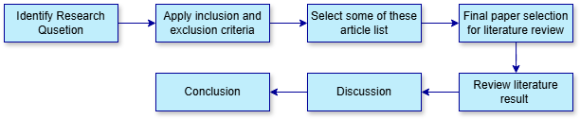

Figure 1. Workflow of This Systematic Review

Research Questions
This study begins by formulating several research questions to guide the focus of this review. The primary question addressed is how the Internet of Things (IoT) is applied in water quality monitoring within the aquaculture sector. The research questions also focus on the effectiveness, benefits, and challenges encountered in implementing IoT technology in this field.
Table 1. Research Questions
ID |  | Research Questions
RQ1 |  | How does the integration of IoT technology Improve the accuracy and real-time capabilities of water quality monitoring?
RQ2 |  | To what extent can IoT-based sensors and data analytics reduce the risk and Impact of water Pollutants?
RQ3 |  | What are the main obstacles in implementing IoT system for water quality monitoring in the aquaculture sector?
RQ3.1 What are technical, operational, and economic barries to implementing IoT systems?
RQ3.2 How can the obstacles to implementing IoT water quality monitoring be overcome?

The aim of this study is to investigate the integration of IoT technology into water quality monitoring systems and assess its reported effectiveness in existing research. An important objective is to identify challenges and suggest solutions for future advancements. Table 1 presents the research questions driving this systematic review. The first research question (RQ1) seeks to explore how IoT technology contributes to the improvement of accuracy and real-time monitoring capabilities for water quality. The second question (RQ2) examines the role of IoT-based sensors and data analytics in minimizing the risks and impacts associated with water pollutants. The third research question (RQ3) focuses on uncovering the primary challenges in implementing IoT solutions for water quality monitoring in the aquaculture industry, including technical, operational, and economic hurdles (RQ3.1), and explores potential strategies to overcome these obstacles (RQ3.2). This comprehensive review will offer valuable insights into the current state of IoT in water monitoring and suggest pathways for future enhancements.
Selection Process
The inclusion and exclusion process for selecting relevant articles was guided by specific criteria to ensure the quality and focus of the literature reviewed. This selection process aimed to identify studies that examined the use of IoT technology specifically for water quality monitoring. Articles were initially screened for relevance, including only those that directly addressed IoT applications in this context. Studies that discussed unrelated uses of IoT were excluded. Additional screening criteria
Included methodological rigor, with a focus on empirical studies involving field experiments, simulations, or other practical applications demonstrating the effectiveness of IoT systems. Theoretical or conceptual studies without empirical support were not considered. Accessibility was another important criterion, ensuring that only articles that were readily available for review were included, while inaccessible sources were excluded. To maintain the uniqueness and integrity of the dataset, duplicate articles were removed. Only articles written in English and published within the past five years were considered, ensuring that the reviewed literature was both accessible and current. These criteria collectively ensured that the selected articles provided relevant, high-quality insights into the use of IoT for water quality monitoring, supporting a focused and timely review of existing research.
Table 2. Inclusion and Exclusion Criteria
Focus Area |  | Inclusion Criteria | Exclusion Criteria
Topik Relevance |  | Articles discussing the use of IoT technology for monitoring water quality | Maximum (include title and abstract) Articles not focused on IoT applications in water quality monitoring.
Methodology |  | Research using empirical methods, including field studies, experiments, or simulations to measure effectiveness of IoT system. | Theoretical studies without verifiable empirical data or experiments demonstrating real impacts.
Accessbility |  | Accessible | Not accessible
Title  Uniqueness  Language  Publication  Age |  | Only One  copy of each title is included  Written in English  Articles  Articles published within the last 5 years | Duplicate  Title  Not written in English  Articles  Articles published more than 5 years ago.

The PRISMA diagram belowillustrates the article selection and screening process utilized. During the Identification stage, article searches were conducted through three main databases: Scopus, IOP, and MDPI. In Scopus, the search used keyword combinations like "water quality monitoring," "Internet of Things," and "fish farming," yielding 421 articles based on titles, 10 articles with the keyword "Internet of Things," and 126 articles with keywords related to IoT.

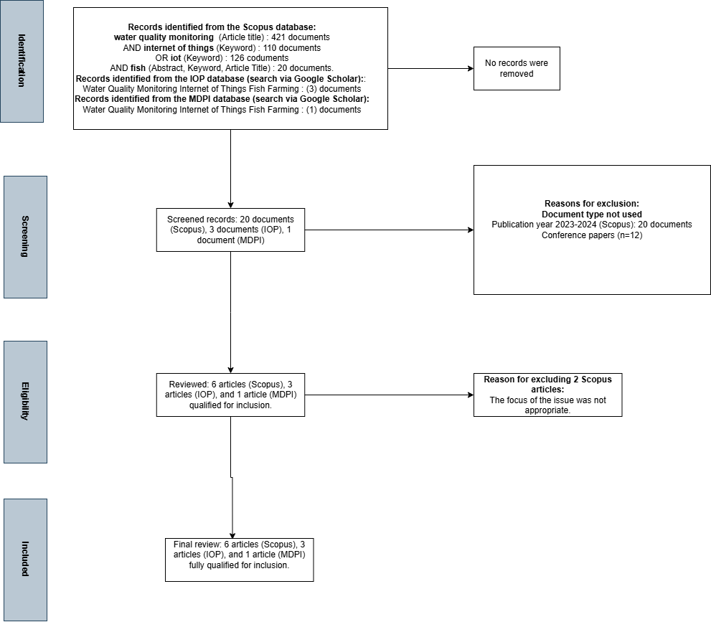

Figure 2. PRISMA Flowchart of Study Selection Process.

Additionally, the Scopus search yielded 20 more articles with the keyword "fish" in abstracts, keywords, or titles. In the IOP database via Google Scholar, 3 relevant articles on the same topic were found, while the MDPI search produced 1 article.No records were removed at this stage, and all articles from the search results proceeded to the screening stage. In the Screening stage, identified articles were filtered to assess their suitability and relevance to the research objectives. During this process, several articles from Scopus were eliminated for reasons such as not meeting the desired document type (published in 2023–2024), and 12 conference papers were deemed less relevant to the review's objectives. After screening, 20 documents from Scopus, 3 from IOP, and 1 from MDPI remained.
The Eligibility stage involved further evaluation of the screened articles to ensure their alignment with the research topic. Based on this evaluation, 6 articles from Scopus, 3 from IOP, and 1 from MDPI were found to meet the criteria and were included in the analysis. However, 2 articles from Scopus were excluded as their problem focus was not relevant to the purpose of this systematic review. Finally, in the concluding stage, a total of 10 articles were selected for inclusion in the final analysis. These articles comprise 6 from Scopus, 3 from IOP, and 1 from MDPI, all considered relevant and providing sufficient data for further analysis on the utilization of IoT in water quality monitoring within aquaculture.

Data Extraction and Analysis Process
In this systematic review, data from studies that met the inclusion criteria were collected to identify key patterns related to Internet of Things (IoT) Utilization in Water Quality Monitoring for Sustainable Fish Farming. The extracted results included information on the water quality parameters monitored, challenges in implementing IoT technologies, and proposed solutions. The data from each study is summarized in a table to facilitate comparative analysis and understand the contributions and challenges of IoT in this field.
Table 3. Selection and Analysis Result
Name of Category |  | Number of Studies | Description
Topic Relevance |  | 10 | A study that discusses the application of IoT in water quality monitoring in aquaculture
Methodology |  | 10 | Empirical studies using field experiments, simulations, or practical studies to measure the effectiveness of IoT in monitoring systems
Water Monitoring Parameters |  | - | Common parameters include temperature, pH, dissolved oxygen, turbidity, and ammonia levels.
Technical Challenges  Economic Challenges  Operational Challenges  Potential Solutions |  | 8  5  4  - | Challenges related to sensor robustness in aquatic environments, sensor calibration, and connectivity in remote areas  High initial cost, ongoing maintenance, and limited financial resources for small-scale aquaculture businesses.  The need for experts for IoT data interpretation, skills training, and data security issues.  Financial incentives, specialized training, durable sensors, more reliable connectivity, and cloud-based data storage solutions.

In addition, the PRISMA Flowchart in the document shows that of the total articles found in the initial search, only 10 articles met the inclusion criteria and were finally included in the analysis.
The following graph displays the distribution of studies based on the main challenges faced in utilizing IoT for water quality monitoring:

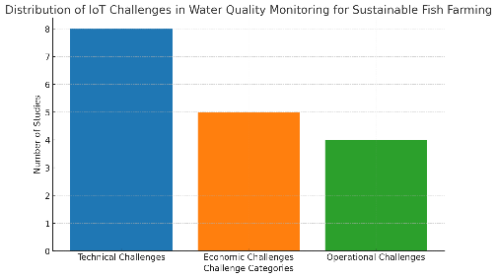

Figure 3. Distribution Graph

This graph displays the number of studies that identified technical, economic, and operational challenges, helping to highlight key areas that require attention in IoT implementations.

FINDINGS AND DISCUSSION
Effective water quality monitoring is a fundamental element in supporting the sustainability of the aquaculture sector. With increasing environmental challenges and the need to improve operational efficiency, Internet of Things (IoT) technology has become a potential solution. IoT integration not only enables real-time data collection but also supports more in-depth data analysis to ensure water quality remains optimal. However, the implementation of IoT in this field is not free from technical, operational, and economic barriers that require strategic solutions.
The results and discussion section of this study provides an in-depth understanding of the benefits and challenges of implementing IoT in water quality monitoring in aquaculture. The discussion focuses on how IoT can improve accuracy, efficiency, and early detection of water pollutants, and explores solutions to overcome obstacles. The findings presented not only enrich the scientific literature but also provide practical recommendations to support the widespread adoption of IoT technologies in this sector.

Findings
This section presents key findings from a systematic analysis of the application of the Internet of Things (IoT) in water quality monitoring in aquaculture. The findings are divided based on three main research questions:
- How IoT improves the accuracy and capability of real-time monitoring,
- To what extent IoT-based sensors and data analytics help reduce the risk of water pollutants, and
- Key barriers to the implementation of IoT systems and solutions to overcome them.
Each finding is supported by empirical studies that demonstrate the advantages of IoT in improving monitoring quality, while noting challenges such as high costs, technical constraints, and limited infrastructure, especially in remote areas.
Table 4. Research Questions Result
ID |  | Research Questions
RQ 1 IoT Integration and Water Quality Monitoring |  | Integrating IoT technology in aquaculture significantly enhances the accuracy and efficiency of water quality monitoring by enabling continuous, real-time data collection on essential parameters such as dissolved oxygen, pH, temperature, and salinity. These IoT-based systems provide immediate feedback via sensor networks, allowing for precise and timely interventions that are crucial for maintaining optimal fish health. Studies show that IoT’s capability to instantly capture and transmit data minimizes human error and reduces delays typical in traditional monitoring methods, thus improving overall water quality management and boosting productivity. For example, in one study, a monitoring system achieved high sensitivity and specificity in detecting pH values across multiple fishpond settings, though with minor limitations in sensitivity at higher pH levels (Putra et al., 2024). Another study integrating various sensors for water quality tracking showed error rates below 7% and accuracy rates ranging from 87-97% for different parameters. These findings underscore IoT’s value in enhancing real-time, reliable monitoring. Systems like AquaBot use multiple sensors and machine learning algorithms to match fish species to specific water quality parameters, improving monitoring accuracy through real-time data (Chen et al., 2022). Similarly, the Firebase-based system collects data in real time via cloud storage, enabling farmers to monitor water conditions on an Android app, which is crucial for maintaining fishpond health. IoT applications, such as those implemented in the "Tutut Jaya" group, have demonstrated improvements in water quality and fish productivity by providing real-time measurements and allowing automated control systems to promptly correct fluctuations in water parameters, stabilizing pH and improving water conditions (Fitriana et al., 2024).
RQ 2 IoT Sensors and Data Analytics in Reducing Water Pollutants |  | IoT sensors, integrated with advanced data analytics, are essential in detecting and reducing water pollutants in aquaculture. By continuously monitoring pollutant levels, such as ammonia and nitrites, IoT devices help identify deviations from safe parameters often caused by waste accumulation or environmental fluctuations. Data analytics enhances this process by analyzing patterns and predicting potential pollution events, allowing for proactive measures to prevent harmful compound buildup. This early detection and intervention are vital in maintaining a healthy aquatic environment, as they significantly reduce the risk of pollution-related mortality in fish farms (Chen et al., 2022). Systems like AquaBot, for example, utilize machine learning to analyze data from multiple sensors, making informed recommendations on suitable fish species to avoid incompatibility with pond conditions. Similarly, Firebase-based systems detect early signs of pollution or poor water quality, enabling farmers to take immediate corrective actions. These IoT-driven systems, with real-time data capabilities, ensure that water quality remains within safe thresholds by triggering responses like activating pumps or adjusting pH levels. Moreover, machine learning in data analytics could further improve pollutant control by enabling these systems to predict and respond to changes in a dynamic, timely manner (Sung et al., 2023).
RQ3 Barriers to IoT Implementations in Aquaculture |  | What are the main obstacles in implementing IoT system for water quality monitoring in the aquaculture sector? The adoption of IoT in aquaculture faces a range of technical, operational, and economic challenges that limit its widespread use. Technically, IoT sensors must withstand harsh aquatic conditions, including fluctuations in temperature, salinity, and organic matter exposure, which can degrade their performance over time. Connectivity issues in remote locations where many aquaculture farms are based further complicated implementation, as stable internet access is essential for real-time monitoring and data transmission. Operational challenges include the need for specialized knowledge to manage and interpret IoT data effectively, a skill set that many aquaculture operators may lack (Nayoun et al., 2024). Data security concerns also arise, as IoT systems involve the transmission of sensitive information that could be at risk without proper safeguards. Economically, the initial investment in IoT technology—covering costs for installation, maintenance, and occasional sensor replacement—can be prohibitively high, especially for smaller farms. Addressing these barriers requires solutions such as financial incentives, targeted training programs, improved sensor durability, enhanced connectivity options, and secure data management protocols (Ya’acob et al., 2021).
RQ3.1 Technical, Operations, and Economics Barriers

The implementation of IoT in aquaculture faces several significant barriers across technical, operational, and economic dimensions. Technically, the durability of sensors in aquatic environments presents a major challenge, as does ensuring consistent connectivity, especially in remote areas where internet access may be limited (Putra et al., 2024). Additionally, sensor calibration is essential for accurate measurements of parameters like pH and turbidity, and environmental factors such as temperature and humidity fluctuations can interfere with readings, necessitating regular maintenance. Operationally, managing IoT systems requires skilled personnel capable of interpreting complex data, which can be daunting for farmers who may lack the technical expertise (Hemal et al., 2024). Furthermore, data security is a concern, given the increasing digitization of farming operations. Economically, the high initial investment and ongoing maintenance costs of IoT devices can be prohibitive, particularly for smaller farms with limited financial resources. The need for reliable power sources and the costs associated with ensuring system stability also add to the economic burden. These technical, operational, and economic challenges collectively hinder the widespread adoption of IoT in aquaculture, particularly among small-scale farmers who may lack both the financial and technical resources to overcome these barriers (Chen et al., 2022).

RQ3.2 Solutions to Overcome IoT Obstacles
Addressing the barriers to IoT implementation in aquaculture requires a range of comprehensive solutions. Financial incentives or subsidies could help reduce the economic burden, particularly for smaller farms that may struggle with the high initial costs of IoT adoption. Both studies emphasize the importance of providing targeted training programs to equip aquaculture operators with the necessary skills to manage and maintain IoT systems, which would mitigate operational challenges. Technical solutions, such as developing ruggedized sensors and establishing reliable connectivity options like LoRaWAN or satellite-based systems, are essential to overcome environmental and connectivity issues often faced in remote aquaculture locations. Cost-effective technologies, including low-cost sensors and microcontrollers, as demonstrated in Firebase-based systems, make IoT more affordable for small-scale operations by lowering equipment costs (Sung et al., 2023). Cloud-based data management solutions, like Firebase, are recommended for reducing the need for on-site data storage, thereby lowering costs and simplifying access to data. Ensuring regular maintenance and calibration of sensors can further improve their reliability, which is critical for long-term, effective monitoring (Jibon et al., 2024). Many aquaculture operators, particularly those in small-scale operations, may lack the technical expertise required to handle advanced IoT systems; therefore, additional support through training and maintenance programs is crucial. Financial constraints not only deter initial IoT installation but also limit the ability of smaller farms to maintain and update these systems regularly (Fitriana et al., 2024).

Discussion
The adoption of IoT technology in aquaculture, especially for water quality monitoring, is a significant advancement for sustainable practices. IoT enables real-time data collection on crucial water parameters like dissolved oxygen, pH, temperature, and turbidity, allowing immediate responses to any deviations. This reduces the risks of pollution and supports a healthier aquatic environment. Systems like AquaBot illustrate how IoT can predict water quality changes, facilitating proactive interventions. However, challenges remain. IoT sensors can be affected by biofouling and environmental changes, requiring regular maintenance and recalibration. Connectivity issues in remote areas also complicate data transmission, and while solutions like LoRaWAN exist, their costs can be prohibitive for small-scale farmers. Additionally, IoT systems require technical expertise for data management, which may be a barrier for farmers lacking digital experience. High initial setup costs and ongoing maintenance further limit accessibility for smaller operations. Despite these challenges, a collaborative approach involving technology developers and policymakers can help create durable sensors and affordable solutions. Addressing these issues can make IoT a viable tool for improving water quality and fish health in aquaculture (Belachew et al., 2023).
CONCLUSION
In this systematic review, IoT technology emerges as a transformative tool for water quality monitoring in aquaculture, offering unprecedented accuracy, real-time data availability, and potential for sustainability. IoT systems allow for precise monitoring of key water parameters, such as dissolved oxygen, pH, temperature, and turbidity, which are essential for maintaining an optimal aquatic environment and preventing pollutant buildup. Systems like AquaBot and Firebase- based solutions exemplify how IoT can facilitate proactive water quality management, ensuring faster decision-making and reducing reliance on manual monitoring. This technology has proven especially valuable in early pollutant detection, enabling timely interventions that promote fish health and productivity. However, despite these advancements, significant barriers remain. Technical challenges include sensor durability issues and connectivity limitations, particularly in remote areas, which complicate continuous monitoring and data transmission. Operationally, the need for specialized skills to manage and interpret data from IoT systems is a significant hurdle for small-scale farmers, who may lack the technical expertise required for effective implementation. Economic barriers, such as high initial investment costs, further deter adoption among smaller operations, despite the long-term productivity benefits of IoT technology. Therefore, the widespread adoption of IoT in aquaculture will require innovative solutions such as cost-effective sensors, reliable connectivity options, and training programs tailored to the aquaculture sector’s specific needs. To overcome these barriers, this review suggests a multi-faceted approach that includes financial support, targeted training, and technical innovation. Government subsidies, private investment, and low-cost IoT solutions are essential to enable smaller aquaculture farms to adopt this technology. Technical solutions, including the development of resilient sensor systems and secure data management protocols, will further support IoT integration in aquaculture, while educational programs will equip farmers with the skills necessary to operate and maintain these systems effectively. Ultimately, by fostering an ecosystem of support around IoT adoption in aquaculture, this technology can play a critical role in advancing sustainable fish farming practices, improving productivity, and ensuring environmental stewardship.

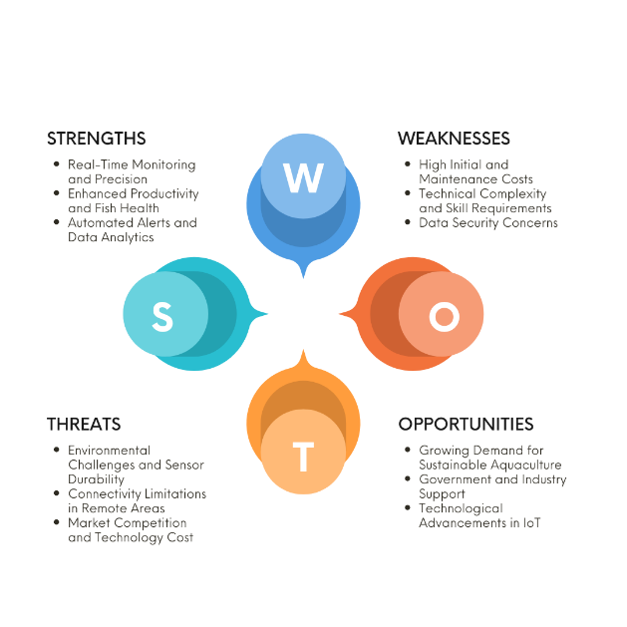

Figure 4. SWOT Analysis

This SWOT analysis highlights the key aspects of implementing IoT technology in aquaculture. The strengths include real-time monitoring and precision, which allow for enhanced productivity and improved fish health through timely interventions. Automated alerts and data analytics contribute to efficient management practices, helping to optimize resources and reduce waste (Arepalli et al., 2024). However, weaknesses such as high initial and maintenance costs, technical complexity, and data security concerns pose challenges for widespread adoption. Opportunities lie in the growing demand for sustainable aquaculture, which is supported by both government and industry initiatives (Riftiarrasyid & Soewito, 2024). Technological advancements in IoT offer further potential for innovation in this field. Nevertheless, the sector faces threats from environmental challenges affecting sensor durability, connectivity issues in remote areas, and high competition and costs within the technology market. Overall, this analysis provides insights into the benefits and challenges of IoT in aquaculture, emphasizing areas for improvement and growth.

ACKNOWLEDGMENT
The authors would like to express their sincere gratitude to all individuals and institutions that contributed to the successful completion of this study. Special thanks are extended to Universitas Atma Jaya Yogyakarta for providing the necessary resources and facilities. We are particularly appreciative of our colleagues and mentors, whose insights and feedback enriched the quality of this research. Lastly, our heartfelt thanks go to our families and friends for their encouragement and understanding throughout the research process. Thank you to everyone who played a part, directly or indirectly, in bringing this work to fruition.
REFERENCES
Arepalli, P. G., Jairam Naik, K., & Rout, J. K. (2024). Aquaculture Water Quality Classification with Sparse Attention Transformers: Leveraging Water and Environmental Parameters. ACM International Conference Proceeding Series, 318–325. https://doi.org/10.1145/3651781.3651829
Babalola, T. E., Babalola, A. D., & Goroti, A. V. (2024). Development of an IoT Based Water Quality Monitoring Device for Domestic Fish Ponds. ABUAD Journal of Engineering Research and Development (AJERD), 7(1), 82–90. https://doi.org/10.53982/ajerd.2024.0701.08-j
Belachew, E. B., Bekele, M. B., & Birawo, B. A. (2023). Intelligent water quality monitoring using WSN and Machine Learning Approaches. ACM International Conference Proceeding Series, 50–55. https://doi.org/10.1145/3603765.3603766
Chen, C. H., Wu, Y. C., Zhang, J. X., & Chen, Y. H. (2022). IoT-Based Fish Farm Water Quality Monitoring System. Sensors, 22(17). https://doi.org/10.3390/s22176700
Fitriana, N., Darmawan, A. A., & Rahmawati, M. F. (2024). INTERNET OF THINGS UNTUK MONITORING KONDISI AIR BUDIDAYA IKAN KELOMPOK ‘ TUTUT JAYA ’ K OTA MALANG. 6(2).
Hemal, M. M., Rahman, A., Nurjahan, Islam, F., Ahmed, S., Kaiser, M. S., & Ahmed, M. R. (2024). An Integrated Smart Pond Water Quality Monitoring and Fish Farming Recommendation Aquabot System. Sensors, 24(11), 1–22. https://doi.org/10.3390/s24113682
Hong, W. J., Shamsuddin, N., Abas, E., Apong, R. A., Masri, Z., Suhaimi, H., Gödeke, S. H., & Noh, M. N. A. (2021). Water quality monitoring with arduino based sensors. Environments - MDPI, 8(1), 1–15. https://doi.org/10.3390/environments8010006
Jibon, F. A., Rafi, F. S., Jamal, Z. B., Anjum, A., & Islam, A. (2024). An Improved IoT-based Prototype for Fish Feeding and Monitoring System AnImprovedIoTbasedPrototypeforFishFeedingandMonitoringSystem. August.
Lotfian Delouee, M., Koldehofe, B., & Degeler, V. (2023). AQuA-CEP: Adaptive Quality-Aware Complex Event Processing in the Internet of Things. DEBS 2023 - Proceedings of the 17th ACM International Conference on Distributed and Event-Based Systems, 13–24. https://doi.org/10.1145/3583678.3596884
Mohd Jais, N. A., Abdullah, A. F., Mohd Kassim, M. S., Abd Karim, M. M., M, A., & Muhadi, N. ‘Atirah. (2024). Improved accuracy in IoT-Based water quality monitoring for aquaculture tanks using low-cost sensors: Asian seabass fish farming. Heliyon, 10(8), e29022. https://doi.org/10.1016/j.heliyon.2024.e29022
Nayoun, N. I., Hossain, S. A., Rezaul, K. M., Noor, K., Islam, S., & Jannat, T. (2024). Internet of Things-Driven Precision in Fish Farming : A Deep Dive into Automated Temperature , Oxygen , and pH Regulation.
Putra, F. P. E., Ubaidi, U., Saputra, R. N., Haris, F. M., & Barokah, S. N. R. (2024). Application of Internet of Things Technology in Monitoring Water Quality in Fishponds. Brilliance: Research of Artificial Intelligence, 4(1), 356–361. https://doi.org/10.47709/brilliance.v4i1.4231
Riftiarrasyid, M. F., & Soewito, B. (2024). Monitoring water quality parameters impacted by Indonesia’s weather using internet of things. Indonesian Journal of Electrical Engineering and Computer Science, 35(3), 1426–1436. https://doi.org/10.11591/ijeecs.v35.i3.pp1426-1436
Singh, Y., & Walingo, T. (2024). Smart Water Quality Monitoring with IoT Wireless Sensor Networks. Sensors, 24(9). https://doi.org/10.3390/s24092871
Sung, W. T., Isa, I. G. T., & Hsiao, S. J. (2023). An IoT-Based Aquaculture Monitoring System Using Firebase. Computers, Materials and Continua, 76(2), 2180–2200. https://doi.org/10.32604/cmc.2023.041022
Tamim, A. T., Begum, H., Shachcho, S. A., Khan, M. M., Yeboah-Akowuah, B., Masud, M., & Al-Amri, J. F. (2022). Development of IoT Based Fish Monitoring System for Aquaculture. Intelligent Automation and Soft Computing, 32(1), 55–71. https://doi.org/10.32604/IASC.2022.021559
Wojew, M., Soeprobowati, T. R., Komala, P. S., & Nastuti, R. (2024). Exploring Spatial Dynamics of Water Quality in a Tropical Lake Affected by Aquaculture. 1–19.
Ya’acob, N., Dzulkefli, N. N. S. N., Yusof, A. L., Kassim, M., Naim, N. F., & Aris, S. S. M. (2021). Water Quality Monitoring System for Fisheries using Internet of Things (IoT). IOP Conference Series: Materials Science and Engineering, 1176(1), 012016. https://doi.org/10.1088/1757-899x/1176/1/012016

