**Development of Moodle-based PJBL Integrated Hybrid Learning Model for Informatics Subjects**

**1Dinda Fitriani HP,2 Darman, &3 Zila Razilu**

1Universitas Muhammadiyah Kendari, Kendari, Southeast Sulawesi

2Universitas Muhammadiyah Kendari, Kendari, Southeast Sulawesi

3Universitas Muhammadiyah Kendari, Kendari, Southeast Sulawesi

* dindafitrianipunoki@gmail.com

|  |  |  |  |
| --- | --- | --- | --- |
| ABSTRACT | | | |
| The development of information and communication technology (ICT) in education has changed the traditional learning paradigm to be more interactive and effective. One of the emerging innovations is the hybrid learning model, which combines face-to-face learning methods with online learning. The main objective of this research is to develop a hybrid learning model integrated with project-based learning with Moodle in informatics subject. This research is included in the development research (R&D) of ADDIE development model. The Moodle-based PJBL Integrated Hybrid Learning Model for Informatics Subjects at SMP Negeri 1 Sampara that has been made is then validated by validators consisting of media validation and material validation, after being validated, a trial is conducted to students, the trial subject is 22 students of class VIII SMP Negeri 1 Sampara. The results of the research on the development of the Moodle-based PJBL Integrated Hybrid Learning Model for Informatics Subjects were declared very feasible based on the results of media validity with an average of 87.18%. and Material Validation 95.51%, and practical use by students based on the results of student trials 85.26%. Thus the Hybrid Learning Model Integrated PJBL Based on Moodle Informatics Subjects at SMP Negeri 1 Sampara, is very feasible to use in informatics learning, and practical to use.  Keywords: ADDIE, Hybrid Learning, Informatics, Moodle, PjBL. | | | |
| **Article history** | | | |
| *Accepted:*  *Date: 9 October 2024* | *Revised:*  *Date: 22 November 2024* | *Accepted:*  *Date: 3 December 2024* | *Published:*  *Date: 2 January 2025* |
|  | | | |

INTRODUCTION

The development of information and communication technology (ICT) in education has changed the traditional learning paradigm to be more interactive and effective. One of the emerging innovations is the hybrid learning model, which combines face-to-face and online learning methods. The hybrid learning model is a combination of face-to-face and online learning that aims to maximise students' learning experience. According to Lord and Lomicka (2008), this model offers greater flexibility, allowing students to learn according to their own pace and learning style. Data from research shows that students who engage in hybrid learning models tend to have better information retention rates compared to traditional learning (Sugiharyanti, 2022). Meanwhile, according toAli Massoud, U. I., Stockley, D., & Noureldin, A. (2011). Using Blended Learning to Foster Education in a Contemporary Classroom. *Transformative Dialogues: Teaching & Learning Journal*, *5*(2), 1–11. (Ali Massoud et al., 2011), hybrid learning can increase student engagement and provide a richer learning experience.

In the context of informatics education, the application of this model is very relevant given the technology-orientated and practical nature of the subject, in addition, hybrid learning provides opportunities for students to access various digital resources that can improve their understanding of the material. For example, students can use video tutorials, discussion forums and interactive quizzes available on Moodle to deepen their understanding of programming concepts.

Moodle, as a popular Learning Management System (LMS) platform, provides various features that support hybrid learning implementation. By using Moodle, teachers can access various learning resources, manage assignments, and interact with students more efficiently. This is in line with the research conducted by Jebari et al. (2017), which showed that the use of Moodle in teaching can improve students' mastery of the material. In this context, the development of Moodle-based hybrid learning for informatics subjects is expected to improve the quality of education and prepare students to face challenges in the digital era. Fausih and Danang (2015) explained that the use of varied learning media can increase students' interest and motivation in learning. Furthermore, the hybrid learning model also supports a more collaborative learning approach. By utilising the forum and group features in Moodle, students can discuss, ask questions and share knowledge with their friends.

This research is important because it provides new insights into the application of hybrid learning models in informatics subjects. In an increasingly connected world, the ability to integrate face-to-face and online learning is a must. This becomes the basis for a more structured and directed hybrid learning development. However, although many institutions have implemented hybrid learning models, there are still gaps in effective implementation, especially in the context of Informatics subjects. Many students still have difficulties in understanding the basic concepts of programming and information systems. Arya Udayana et al. (2017) noted that the lack of interactive and engaging learning media is one of the causes of low student understanding. Therefore, it is important to conduct this research to formulate a more effective learning model that suits the needs of students.

In addition, this research also contributes to the development of more effective and efficient learning methods. By utilising technology, teachers can create a more flexible and adaptive learning environment. Daryanti et al. (2019) emphasised that the right learning media can increase student engagement, so they are more active in the learning process. The novelty of this research lies in the development of a hybrid learning model specific to informatics subjects by utilising Moodle as the main platform. This research focuses on the development of Hybrid Learning and integration with project-based learning (PjBL) method in the subject. Thus, this research not only contributes to the development of learning theory but also provides practical solutions that can be applied in various educational institutions. The main objective of this research is to develop an effective Moodle-based PjBL integrated hybrid learning model for informatics subjects.

METHODS

The research method in this study uses a development research method or Research And Development (R & D), using the ADDIE model which consists of *Analysis*, *Design*, *Development*, *Implementation and Evaluation* (Ibrahim (2011), Pribadi (2016), Almahdali. et al, 2023).

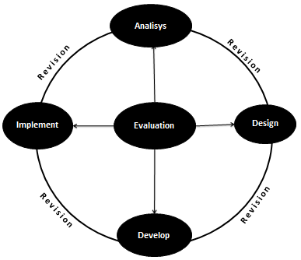

**Figure 1**. Stages of the ADDIE Development Model

This research has been carried out, namely the Development of a Moodle-based Hybrid Learning Model for Informatics Class VII Odd Semester, which was carried out at SMP Negeri 1 Sampara, Konawe Regency.

The data collection technique used is an instrument / questionnaire with a Liker scale ranging from 1 to 4, with conversions as in table 1.

**Table 1**.Liker Scale Conversion

|  |  |
| --- | --- |
| **Range** | **Convert** |
| 1 | Strongly Disagree |
| 2 | Disagree |
| 3 | Agree |
| 4 | Strongly Agree |

In addition, observations and interviews were also used. Observations and interviews were used to analyse the needs of teachers and students related to learning media and learning materials.

According to Sugiono (2016) the percentage of expert validation on average for each component is calculated using the formula:

P = $\frac{∑x}{N}$ x 100%

Description:

P = the acquisition of the percentage of validators (rounded up to reach a whole number)

Σx = Number of scores for each criterion

N = Number of ideal scores

**Table 2**. Qualification of achievement levels

|  |  |  |
| --- | --- | --- |
| **Achievement Level** | **Qualification** | **Description** |
| 76%-100% | Very good | Very Good, No need to revise |
| 51%-75% | Good | Appropriate, Needs revision |
| 36%-50% | Simply | Feasible, Needs revision |
| <35% | Less good | Not Feasible, Total Revision |

Source: Arikunto (2010) and researcher modification

Meanwhile, data from student responses were analysed using the Purwanto formula (2017: 102) in the following way:

NP = $\frac{R}{SM}$ x 100%

Description:

NP = Percentage value sought

R = Raw score obtained

SM = Maximum score

**Table 3.** Practicality Criteria

|  |  |
| --- | --- |
| **Range** | **Category** |
| 86%-100% | Very Practical |
| 76%-85% | Practical |
| 60%-75% | Practical enough |
| 55%-59% | Less Practical |
| <54% | Not Practical |

FINDINGS AND DISCUSSION

Findings

The results of research on the development of a Moodle-based Hybrid Learning model for Informatics subjects made using the ADDIE development model. The stages of the ADDIE model (Almahdali. et al, 2023) are as follows:

1. Analysis stage

In this analysis stage, the needs analysis is carried out as a basic step to determine the needs to be used in the development of the Hybrid Learning Model for Informatics Subjects. The needs analysis in this study is an analysis of the needs of teachers and students related to the need for learning media, with reference to the media used during learning. From the results of direct observation, the media used are still limited to package books, Power Point Slides (PPT). In addition to needs analysis, content analysis is also carried out related to the content of the application to be developed, namely material that is relevant to learning outcomes and learning elements that will be studied for 1 semester.

1. Design Stage

After analysing, then create a *flowchat* that aims to facilitate its development.

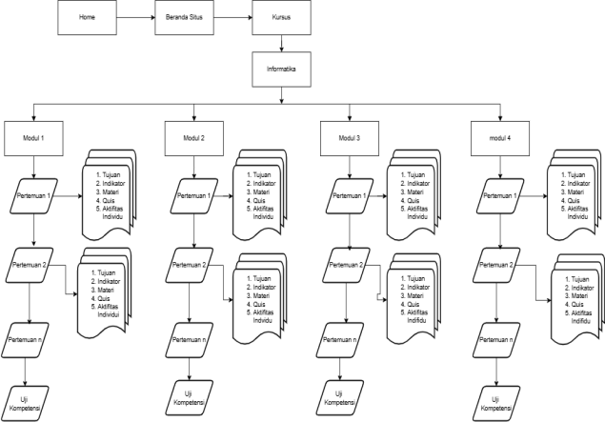

**Figure 2**. Flowchart Design Stage

1. Development Stage

The development stage was carried out based on the flowchart in Figure 2 above. The materials that have been prepared are then arranged on the moodle platform.

1. My Course Page Display

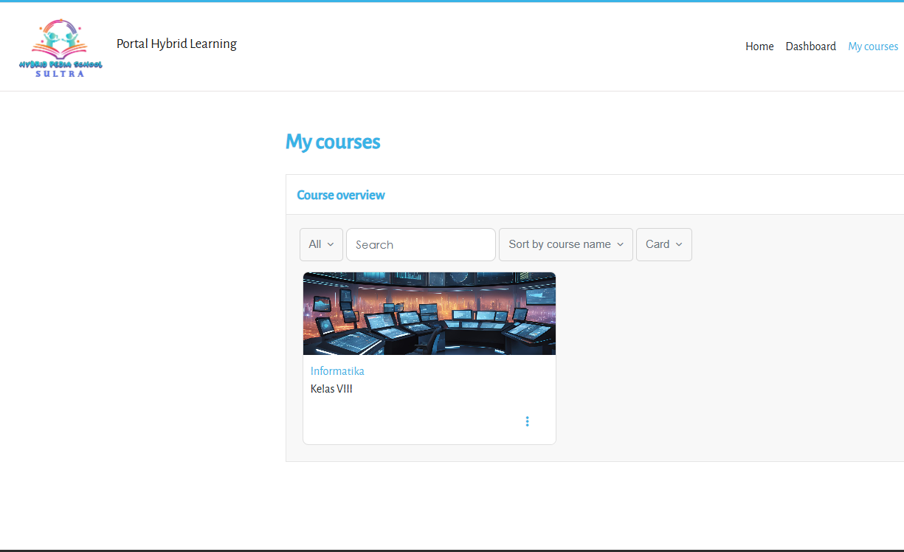

**Figure 3.** My Course Page Display

1. Module 1 Page View

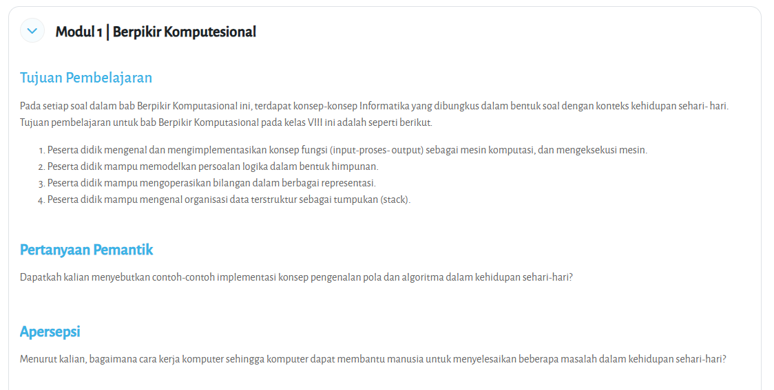

**Figure 4.** Module 1 Page View

1. Display of Meeting Page 1

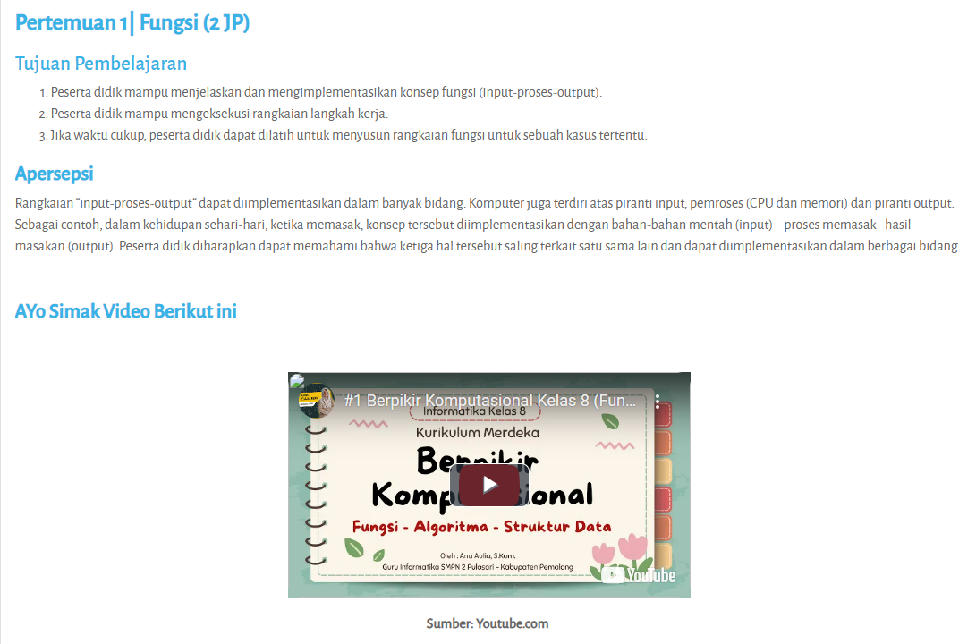

**Figure 5.** Display of Meeting Page 1

1. Self Activity Page Display

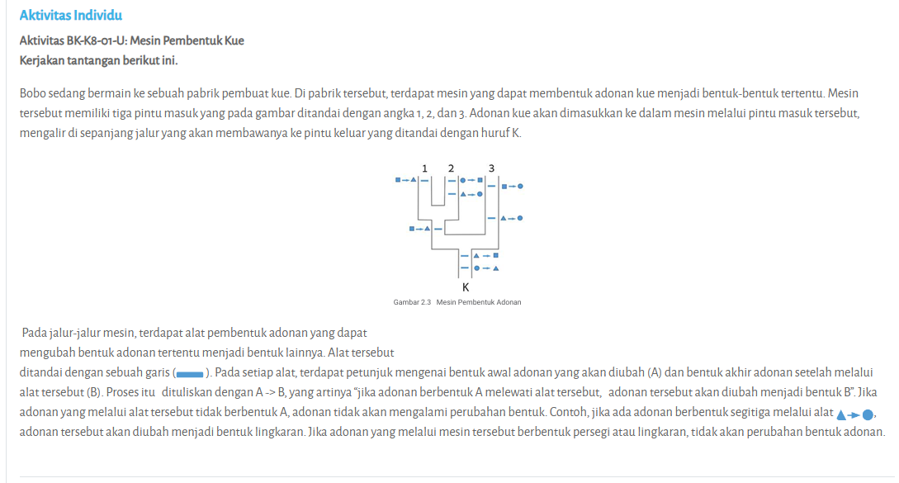

**Figure 6.** Independent Activity Page Display

1. Quiz Page Display

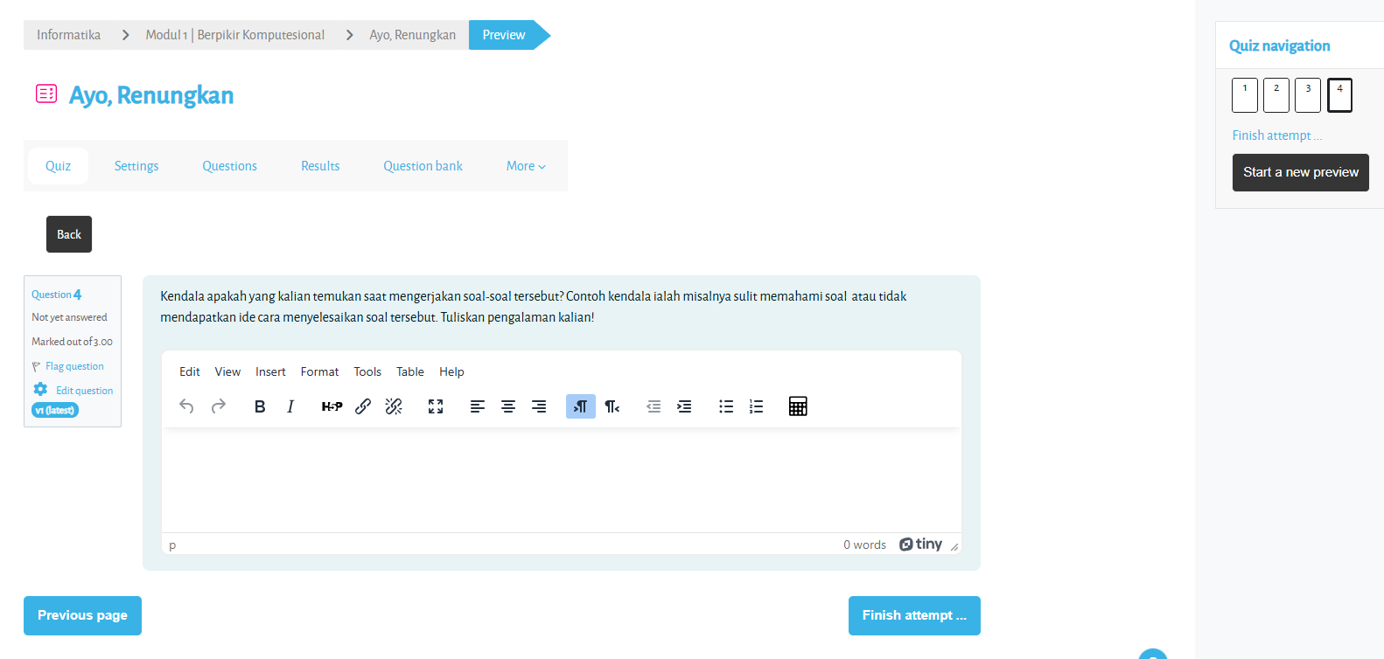

**Figure 7.** Quiz Page Display

1. Competency Test Page Display

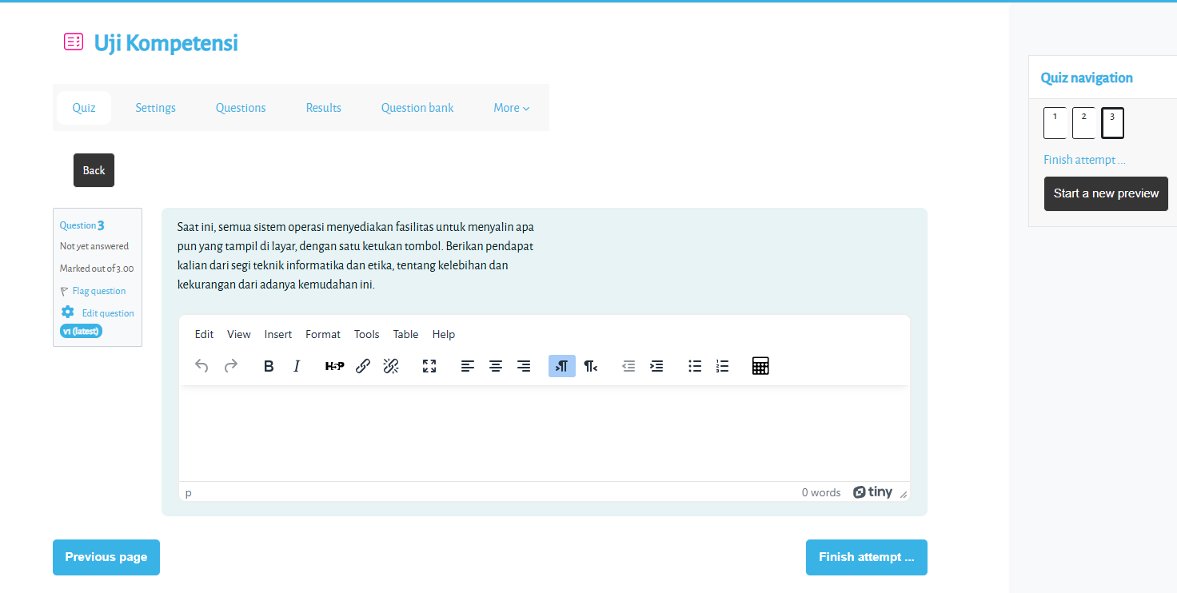

**Figure 8.** Cometency Test Page Display

After the media has been developed, validation will be carried out. This validation aims to determine the feasibility of the model developed. The validation that will be carried out is media validation and material validation.

Media Validation.

Media validation was carried out by 3 expert lecturers of the Information Systems and Technology Study Programme. This media validation is to measure the level of feasibility in terms of appearance, navigation, media interactivity, content, system. The results of the media expert assessment can be seen in Figure 9.

**Figure 9.** Media Expert Validation Results

Based on Figure 9 above, it is known that the results of media validation from the display aspect obtained a value of 84.88%, the navigation aspect obtained a value of 85.00%, the media interactivity aspect obtained a value of 90.00%, the content aspect obtained a value of 89.06%, and the system aspect obtained 86.96%, overall obtained an average of 87.18%. From this data if based on table 2, it is included in very good qualifications with a very feasible level, no need for revision (Arikunto, 2010).

Material Validation

Material validation was carried out by 2 Informatics subject teachers. This material validation is reviewed from the aspects of material, language use, evaluation, and PjBL. The assessment results can be seen in Figure 10 below.

**Figure 10.** Material Validation Results

From Figure 10, it is known that the results of material validation from the Material aspect obtained a score of 96.43%, the Language Use aspect obtained a score of 96.43%, the Evaluation aspect obtained a score of 92.14%, and the PjBl aspect obtained a score of 97.02%. Overall, the material validation results obtained an average of 95.51%. From this data if based on table 2, it is included in very good qualifications with a very feasible level, no need for revision (Arikunto, 2010).

.

1. Implementation Stage

The research continued at the *Implmentation* stage, aiming to apply Moodle-based Hybrid Learning learning media in information learning in class VIII SMP Negeri 1 Sampara. The trial subjects were 22 students of class VIII, the teacher used Hybrid Learning as a tool in the learning process. After being taught to use the application, students are asked to fill out an instrument sheet. This instrument is related to hybrid learning and PjBL. The results of the student trial can be seen in Figure 11.

**Figure 11.** Student trial results

Based on the data from Figure 11 above, it is known that the results of the student coma test from the Hybrid learning aspect obtained a score of 85.11%, and the PjBL aspect obtained a score of 85.40%, overall the student trial results obtained an average of 85.26%, From this data if based on table 3, it is included in the range 76%-85%, Practical Category (Purwanto, 2017).

1. Evaluation stage

The evaluation stage is carried out by evaluating the results of media validation and Material Validation. Overall media validation obtained an average of 87.18%. interpreted as very feasible. Thus based on Media Validation, it can be concluded that the Moodle-based Hybrid Learning model for Informatics subjects at SMP Negeri 1 Sampara is very feasible to use.

Furthermore, the overall material validation results obtained an average of 95.51%, interpreted as very feasible. From the evaluation results of media validation and material validation, there are no suggestions for improvement from the validators, so that the development of the Moodle-based Hybrid Learning model for Informatics subjects at SMP Negeri 1 has no revisions. The next evaluation is based on the results of student trials, the results of student trials obtained an average of 85.26%, included in the Practical Category, thus concluding that the Moodle-based Hybrid Learning Model for Informatics subjects at SMP Negeri 1 is practically used by students.

**Discussion**

Blended learning has become an increasingly popular alternative in modern education. It combines face-to-face learning methods with online learning, creating a learning environment that is more flexible and responsive to student needs. In this context, blended learning not only increases time effectiveness, but also offers cost efficiency and greater appeal in human interaction in a diverse learning environment. With this approach, students have the opportunity to learn both together and separately, at the same or different times, allowing them to customise their learning experience according to their individual styles and needs.

The Moodle-based Project-Based Learning (PJBL) Integrated Hybrid Learning Model is one of the concrete implementations of blended learning that has been developed using the ADDIE (Analysis, Design, Development, Implementation, Evaluation) model. The process starts with analysing students' needs and characteristics, followed by designing relevant and interesting materials. The use of Moodle as an online learning platform provides easy access and management of materials, so that students can learn independently outside of school hours. Validation conducted by experts showed that this model is very feasible to implement, with media validity scores reaching 87.18% and material validity 95.51%. These figures indicate that both the content and methods used have met the set standards, giving educators the confidence to implement it. The trial conducted to 22 students of class VIII SMP Negeri 1 Sampara showed satisfactory results, with the practical use score reaching 85.26%. This indicates that students felt comfortable and helped by using this hybrid learning model in their learning process. In the context of education, convenience and practicality are important factors that can influence student motivation and engagement. For example, students who have busy schedules outside of school can access learning materials anytime and anywhere, so they do not feel left behind compared to their classmates. One important aspect of blended learning is its ability to enhance social interaction among students. In traditional learning environments, interaction is often limited to a specific time and space. However, with the hybrid learning model, students can collaborate on group projects both in person and through online platforms. For example, in a PJBL project, students can discuss and work together in completing their assignments, both in class and through a discussion forum on Moodle. This not only improves understanding of the material, but also social and co-operation skills which are crucial in today's working world. The results of this study were corroborated by Moskal (2013) who showed that hybrid learning programmes have the potential to improve student learning outcomes and also reduce dropout rates compared to fully online learning. This can be explained by the fact that blended learning provides a balance between direct interaction with teachers and peers, and the flexibility offered by online learning. Students who feel connected to a learning community tend to be more motivated to stay engaged in the learning process, which in turn can reduce dropout rates.

CONCLUSIONS

The development of the Moodle-based Hybrid Learning Model for Informatics Subjects at SMP Negeri 1 Sampara, was developed using the ADDIE model which consists of *Analysis*, *Design*, *Development*, *Implementation and Evaluation*. The results of this development produced a Moodle-based Hybrid Learning Model for Informatics Subjects at SMP Negeri 1 Sampara.

The overall Media Validation results obtained an average of 87.18%. interpreted as very feasible. The overall Material Validation results obtained an average of 95.51%, interpreted as very feasible. Thus, based on Media Validation and Material Validation, it can be concluded that the Moodle-based Hybrid Learning model for Informatics subjects at SMP Negeri 1 Sampara is very feasible to use for learning Informatics.

The results of the student trial obtained an average of 85.26%, included in the Practical Category, thus concluding that the Moodle-based Hybrid Learning Model for Informatics subjects at SMP Negeri 1 Sampara is practically used by students.

**ACKNOWLEDGEMENTS**

My gratitude goes to Mr Darman, S. Pd., M. Pd, as the Chief Researcher, who has involved me in Ristek Dikti research Year 2024.

REFERENCES

Ali Massoud, Umar Iqbal, Denise Stockley, and Aboelmagd Noureldin. 2011. "Using Blended Learning to Foster Education in a Contemporary Classroom." *Transformative Dialogues: Teaching & Learning Journal* 5(2):1-11

Almahdali, H., Pane, E. P., Rukmana, A. Y., Nasution, A. K. P., Jannah, L. U., & Razilu, Z. (2023). New Technologies In Teaching And Learning. Get Press Indonesia.

Arikunto, S. (2010). Research Methods. Jakarta: Bumi Aksara.

Arya Udayana, Ngurah Nyoman, I. Made Agus Wirawan, and Dewa Gede Hendra Divayana. 2017. "Development of E-Modules on Object-Oriented Programming Subjects with Project Based Learning Model for Class XII Software Engineering at SMK Negeri 2 Tabanan." *National Journal of Informatics Engineering Education (JANAPATI)* 6(2):128. doi: 10.23887/janapati.v6i2.9373.

Daryanti, Daryanti, Desyandri Desyandri, and Yanti Fitria. 2019. "The Role of Media in Learning Cultural Arts and Skills in Elementary Schools." *Edukatif: Journal of Educational Sciences* 1(3):215-21. doi: 10.31004/edukatif.v1i3.46.

Fausih, Moh, and T. Danang. 2015. "Development of E-Module Media for Productive Subjects 'Lan Network Installation (Local Area Network)' for Xi Class Students of Network Computer Engineering Department at Smk Nengeri 1 Labang Bangkalan Madura." *UNESA Journal* 01(01):1-9.

Fausih, Moh, and T. Danang. 2015. "Development of E-Module Media for Productive Subjects 'Lan Network Installation (Local Area Network)' for Xi Class Students of Network Computer Engineering Department at Smk Nengeri 1 Labang Bangkalan Madura." *UNESA Journal* 01(01):1-9.

Ibrahim, Reyzal. 2011. ADDIE Development Model. Surabaya: Jaya Publishing.

Jebari, Khalid, Faouzi Boussedra, and Aziz Ettouhami. 2017. "Teaching 'information Systems Management' with Moodle." *International Journal of Emerging Technologies in Learning* 12(4):4-16. doi: 10.3991/ijet.v12i04.6183.

Lord, Gillian, and Lara Lomicka. 2008. "Blended Learning in Teacher Education: An Investigation of Classroom Community Across Media." 8:158-74.

Moskal, Patsy, Charles Dziuban, and Joel Hartman. "Blended learning: A dangerous idea?" The internet and higher education 18 (2013): 15-23.

Pribadi, Benny. 2016. Learning System Design Model Jakarta: Dian Rakyat.

Purwanto. (2017). Prinsip-Prinsip dan Teknik Evaluasi Pengajaran. Bandung: PT Remaja Rosdakarya.

Sugiharyanti, Endang. 2022. "Application of Project Based Learning Model Assisted by Moodle E-Learning to Improve English Learning Achievement." *Ideguru: Journal of Teacher Scientific Work* 7(2):212-20. doi: 10.51169/ideguru.v7i2.364.